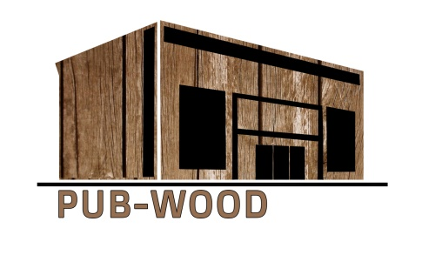

***Prepared by Assoc. Prof. Dr Laura Tupenaite, VGTU***

**Tasks**

1. **What is the difference between INSPECTION and CONTROL? Explain.**
2. **Name at least 5 categories of problems that normally occur during construction:**
3. **The G. J. Company has a contract for rehabilitation of three timber houses. The work consists primarily of addition insulation. On the day insulation work started, the Daily Report stated: "Started insulation work today. Everything looked okay." Is this report feature adequate? Explain.**
4. **Contractor is constructing a timber building. The contract was awarded in April, which allowed for sufficient time to enclose the building before onset of cold weather. Building is scheduled to be complete in May of next year, which necessitates doing the inside finish work during winter months. The client/customer has scheduled delivery of equipment and stock for June. Work was progressing satisfactorily and the contractor was about to start roofing operations in mid-September when the resident engineer discovered the contractor was installing untreated lumber for edge strips, curbing, etc., which was in violation of the specifications. Work was stopped, and after some investigation, contractor advised the resident engineer that the best delivery on treated lumber was eight weeks, which would delay enclosing the building and ultimately delay turnover to the client/customer. The contractor requested waiver of treated lumber requirement.**
5. **Where did the contractor’s control system break down?**

**2) How to solve the problem?**

1. **Contractor on a major multi-building project started his first concrete placement this morning. Contractor is placing a monolithic foundation using a leased concrete pump truck. Two-thirds of the foundation had been placed when the concrete pump failed. No standby placement equipment was available as required by the contract, which created a cold joint before the pump could be repaired.**
2. **What was the first step that failed in the contractor's Quality Control program?**
3. **What corrective measures should the contractor employ to prevent further incidents of this type?**