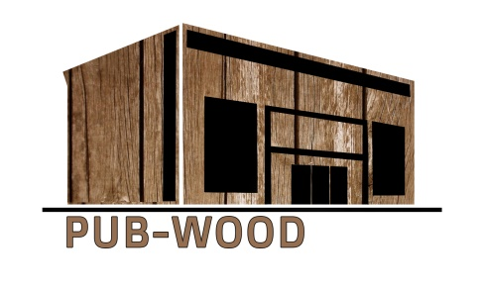

**Sustainable Public Buildings Designed and Constructed in Wood (Pub-Wood)**

**Project number: 2018-1-LT01-KA203-046963**

**Title**

**……., 2019**

# TITLE

Text Text Text Text Text Text Text Text Text Text Text Text Text Text Text Text Text Text Text Text Text Text Text Text Text Text Text Text Text Text Text Text Text Text Text Text Text Text Text Text Text Text Text Text Text Text Text Text Text Text Text Text Text Text Text Text Text Text Text Text Text Text Text Text Text Text Text Text Text Text Text Text Text Text Text Text Text Text Text Text Text Text.

Text Text Text Text Text Text Text Text Text Text Text Text Text Text Text Text Text Text Text Text Text Text Text Text Text Text Text Text Text Text Text Text Text Text Text Text Text Text Text Text