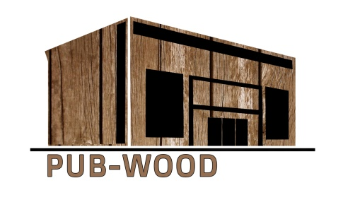


Sustainable Public Buildings Designed and Constructed in Wood (Pub-Wood)
Project number: 2018-1-LT01-KA203-046963

Title

……., 2019

TITLE
Text Text Text Text Text Text Text Text Text Text Text Text Text Text Text Text Text Text Text Text Text Text Text Text Text Text Text Text Text Text Text Text Text Text Text Text Text Text Text Text Text Text Text Text Text Text Text Text Text Text Text Text Text Text Text Text Text Text Text Text Text Text Text Text Text Text Text Text Text Text Text Text Text Text Text Text Text Text Text Text Text Text.
Text Text Text Text Text Text Text Text Text Text Text Text Text Text Text Text Text Text Text Text Text Text Text Text Text Text Text Text Text Text Text Text Text Text Text Text Text Text Text Text

